



Implementation of Directory and Files Management in Python
LAB MANUAL

Disclaimer: The content is curated from online/offline resources and used for educational purpose only
Implementation of Directory and Files Management in Python

Objectives:
- Create new subdirectories within the base directory.
- Read and display the content of specified files.
- Rename existing files in the directory
- Delete specified files from the directory.
- Remove specified directories from the base directory, ensuring they are empty.
- List all files in the specified directory.

Problem Statement:
In this problem is to create a Python program that allows users to manage files and directories efficiently. The program should provide functionalities to create, read, update, delete, and list files and directories within a specified base directory. The system should handle errors gracefully, ensuring a user-friendly experience while managing file operations.
Equipment Required:
- Install VS Code - https://code.visualstudio.com/download
- Download Python Installer File - https://www.python.org/downloads/
Prerequisites:
- Basic Computer Skills - Anyone starting to learn computer programming needs basic computer skills.
- Basics of control statements

Procedure:
Task 1: Implementation of Create a new directory
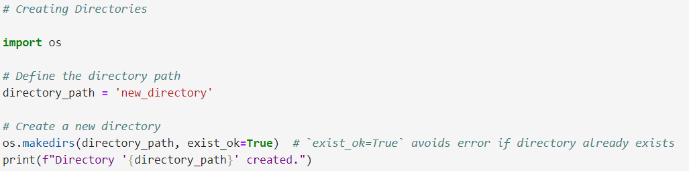

Output:
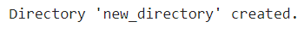
Task 2: Implementation of Rename the directory
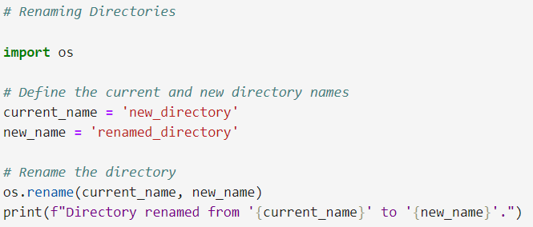
Output:
Task 3: Implementation of Remove the directory and all its contents
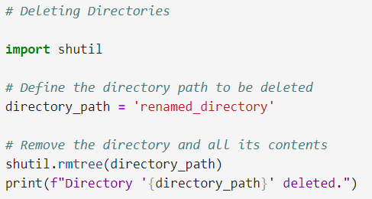
Output:
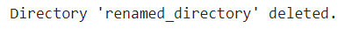

Task 4: Implementation of List all files and directories
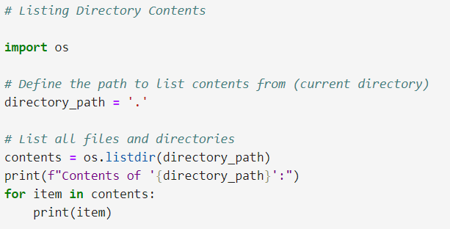
Output:
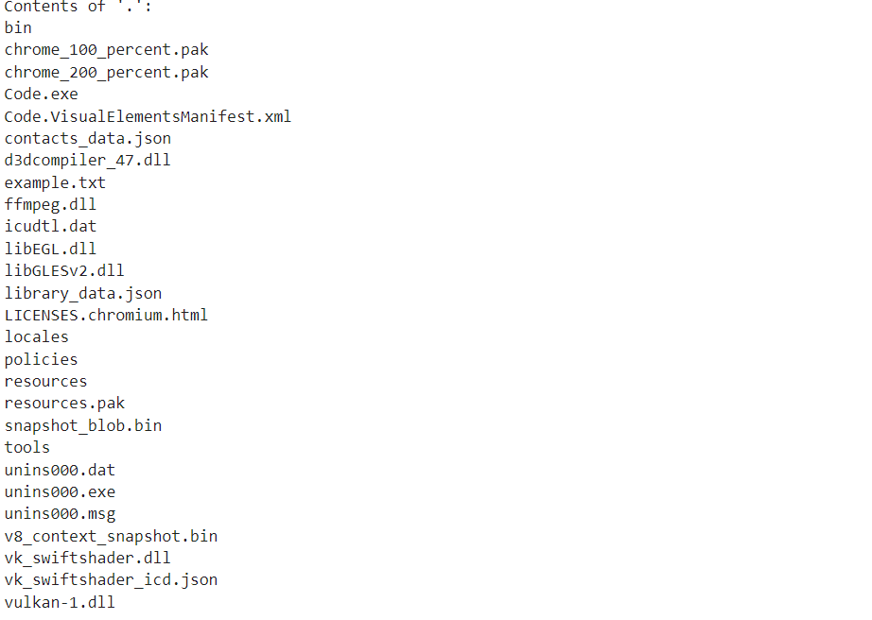

Task 5: Implementation of Navigating Directories
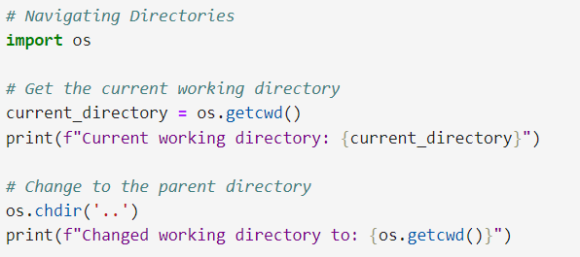
Output:
Task 6: Implementation of Creating and Writing to Files in directory

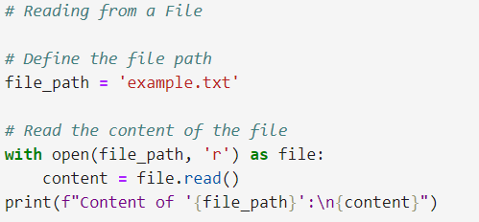
Output:
